Bakewell Baking Festival 2015 – Exhibitor Application Form
Please fill out application and email it to admin@bakewellbakingfestival.co.uk
To ensure that we have we don’t have exhibitors selling similar products, please wait for confirmation of application before submitting payment.

Each exhibitor will be given a pitch size of 3m x 3m and will be required to bring their own Marquee/ Gazebo, Table, Chairs etc. Further space can be booked at £5 per m2.
This price will include Free Weekend Parking next to the festival site and 4 Free Weekend Stroller tickets that allow access to the Baking, Vintage, Food and Drink Village areas.
The Deadline for receipt of your application form (together with your documents) is 7th August 2015
By submitting this form you are agreeing to the Terms and Conditions for Exhibitors.
To promote our local producers and retailers we offer a 10% reduction for any business with a DE45 Post Code.
The look of the festival is incredibly important to us, the visitors and you as exhibitors and we would appreciate you entering into the spirit of the weekend by dressing your stands in a charming vintage style.

Exhibitor Application
CONTACT NAME
COMPANY / TRADING NAME
POSTAL ADDRESS

POST CODE
EMAIL ADDRESS
WEBSITE
TELEPHONE

Exhibitor information—Please provide a brief description of what you will be exhibiting, for us to use in our festival programme and on the website. Also could you describe the colour and style of Marquee/Gazebo etc. that you intend to use.

Have you won any awards? If so please give details. YES NO

Please contact me about Sponsorship opportunities YES NO
I am willing to donate ingredients for the baking demonstrations YES NO

Details of Electricity and Water Usage
Electricity Is available on site at a cost of £20.00 per 13 amp socket but requires power cable to be supplied by exhibitor.
Water taps are also available on site.

Festival Costs
Item | Cost | Total
Stall Pitch Area Outdoors 3 X 3M  Marquee/Gazebo etc. to be supplied by vendor | £150.00 per weekend
Extra Space | £5 per m2
Electricity | £20.00 per 13 amp socket but requires power cable to be supplied by exhibitor.

PAYMENT METHOD

BUSINESS NAME
CONTACT NAME
CONTACT TELEPHONE

CHEQUE PAYMENT: | Office Use:
I enclose a cheque for £  Please make cheques payable to Bakewell Festival Ltd. | Received:

BACS PAYMENT: | Office Use:
Bank: National Westminster
Sort Code: 600133
Account Number: 51160501
Account Name: Bakewell Festival Ltd
Please quote your trading name as reference and advise us of payment by email

Please send any cheques and printed material to Bakewell Festival Ltd, Spire House, North Church Street, Bakewell, DE45 1DB

Name of Local Environmental Health Authority Registered to:
Name of Public, Product & Employee Liability Insurer:
Policy No:
Copy of these documents to be submitted to the Event Organisers at time of booking.
PLEASE TICK (√) the following:
PREFERRED CONTACT VIA | Email | Post
PLEASE CONTACT ME ABOUT SPONSORSHIP OPPORTUNITIES | Yes | No
I AM WILLING TO DONATE INGREDIENTS FOR THE COOKERY DEMONSTRATIONS | Yes | No
SET UP TIME:
Friday 14th August 12.00 – 19.00 and Saturday 15th 7AM – 9.30 AM
Festival Trading Hours –
Saturday 10.am – 18.00 Sunday 10.am – 17.00 Traders are required to keep stalls open within these times

Company information:-
Bakewell Festival Ltd
Registered in England and Wales Company No. 7950350
Registered office: The Lodge, 101 Clarkehouse Road, Sheffield, S10 2LN

Bakewell Baking Festival Terms and conditions

It is understood that in signing for and purchasing exhibitor space at the Bakewell Baking Festival that the festival rules and conditions will be adhered to. The Bakewell Baking Festival is being organised by the Board of Bakewell Festival, subsequently referred to in these terms and conditions as the Event Organisers.

EXHIBITOR APPLICATIONS
Applications for bookings will be taken for the Bakewell Baking Festival in accordance with the Bakewell Baking Festival mission statement. All applications for bookings will be considered by the Event Organisers, whose decision is final.
The deadline for application for bookings is 1st August 2015. Applications may be accepted after this date but will not guarantee a listing in the Festival publicity. All applications for bookings must be accompanied by full payment, either by cheque, card or BACS. NO space can be processed and confirmed without this. We regret refunds will not be given for bookings cancelled by exhibitors.
An application does not guarantee a space at the Festival.
This may be for many reasons (e.g. too many similar stalls or inappropriate to the Festival). The festival office will have the final decision in all cases. A refund will be made for unsuccessful applicants.
All payments for spaces must be pre-paid. No payments or admittance will be accepted on the day.
Where possible the festival office will separate similar products offered for sale but reserves the right to give the public variety and choice. The festival office will make reasonable efforts to satisfy requests to reserve a specific position but for operational reasons this cannot be guaranteed.
We particulary encourage applications from VINTAGE TRADERS

ALLOCATION OF EXHIBITOR SPACE
The Event Organisers will allocate exhibitor space within the area of the Festival. We regret that exhibitors are not able to specify the exact location of their stand. The Event Organisers reserve the right to change the site plan at their discretion.

VEHICLES
The Bakewell Baking Festival is open to the public from 10am and closes at 7pm. All vehicles must be moved to the Exhibitor’s Car Park immediately after unloading. It is essential that you arrive in good time to be fully operational at 10am. No stall is to be taken down before the end of trading at 6pm on Saturday and 5pm on Sunday.
SUB LETTING
We do require relevant information in your application form if you are sharing a stall.

DESCRIPTION OF GOODS
The application form for space must contain an accurate description of goods to be exhibited or sold. Only items of this description will be allowed. All goods sold at the festival should conform to current trading standards legislation. The use of radio microphones, amplification devices and music devices are strictly prohibited unless written permission is given.
Location
Exhibitors selling food, drink or vintage goods, will be located within the Festival Village area (see map) .
Stall Vending Areas
We allow an area of 3m x 3m for each exhibitor if you require more space this is available at £5.00 per m2.
Any requirement for a custom pitch width will be charged on running metre frontage basis. If this involves a vehicle or trailer then the overall dimension (including drawbar, rear or side doors open, trading or frontage fenced area etc) must be indicated.
Please note when booking your stall or pitch that this is for the entire display, including tables and access. Please allow space for personal possessions and stock.
Cancellations
Any exhibitor who cancels a booking, for whatever reason, fails to attend, shall forfeit all fees paid and the festival office shall reserve the right to re-let such sites. No refunds will be given due to bad weather or ground conditions.
Setting Up & Dismantling of Exhibits
Exhibitors are advised that the set-up time will be from 12.00 on the 14th and 7.00 am—9.30 am on the Saturday . Please make sure your exhibit does not extend beyond the area you have booked. Exhibits can be dismantled after 5.00 pm. on the Sunday. All exhibitors should remain on site during opening hours.
Parking for Exhibitors is Free at our Exhibitor Car Park next to the Festival Site
All vehicles must be off site by 9.30 am and will not be able to return to the site until end of trading on Saturday @ 18.00 and Sunday @ 17.00

Security, Licensing & Public Liability Etc.
All exhibitors enter at their own risk.
All exhibitors should ensure that they are adequately insured on the date of the festival for Public, Product and Employees Liability and should send a copy of the relevant document with their application form.
Health and Safety
All exhibitors have a responsibility to ensure the health, safety and welfare of themselves and others. The organiser shall not be held responsible by any exhibitor or their staff/agents or members of the public for any injury or loss due to negligence or unsafe displays.
All exhibitors are required to have carried out an assessment of the potential risks associated with their activities. Please supply a copy of this with your application form.
The organisers shall not be held responsible for loss or damage of stock or equipment, howsoever caused, during the festival.
Fire safety equipment. Exhibitors must provide fire safety equipment appropriate to their activities. In particular, all exhibitors that cook on site must have adequate fire fighting equipment including fire blankets.
Environmental Health & Trading Standards
Food producers should ensure that they are registered with their local authority prior to the Festival. Exhibitors are expected to comply with relevant legislation in respect of Trading Standards, Health and Safety and Environmental Health of Derbyshire County Council.
Stalls may be inspected and those deemed not to comply with relevant regulations will be shut down.
Food producers should ensure that they have an adequate food safety management system, ensuring that the food they prepare and sell is safe to eat.
Please forward copies of your food safety management plan along with your application form.
Waste disposal
Exhibitors are expected to keep their surrounding areas as clean as possible throughout the Festival. Facilities for waste disposal and recycling will be provided on site. Where appropriate, adequate precautions should be taken to prevent oil/fluid spillage by the use of trays underneath all vehicles. Facilities for refuse disposal and recycling will be provided on site. However, exhibitors are responsible for the disposal of any foul water, and we recommend that you take it away with you in a sealed container and empty into a suitable foul drainage system
Electricity
An Electrical Supply consists of one x 13 Amp 240 volt standard domestic socket and should be paid for on your application form.
Extension leads if required (from the supplied unit) are the responsibility of the exhibitor and are not available from the organisers.
Equipment
Exhibitors may bring their own generators onto site, providing that they are SILENT diesel generators and that exhibitors bring suitable fire fighting equipment.
All electrical equipment must be certified and have a current PAT certificate. This certificate must be made available for inspection by our electrician at the Festival.
Please note that non PAT tested equipment cannot be used under any circumstances.
All gas equipment must be covered by a current gas certificate issued by a registered gas engineer. Please forward copies of your PAT and / or gas certificate(s) with your application form.
Disposables
We recommend that all food containers, packaging, plates and cutlery etc. should be constructed of biodegradable materials such as paper and wood. Drinks containers should be recyclable and we prefer recyclable plastic to biodegradable plastic.
If biodegradable drink containers are used, they should be clearly marked.
We strongly recommend that polystyrene and other non-recyclables are not used.

SITE and LOCATION MAPS
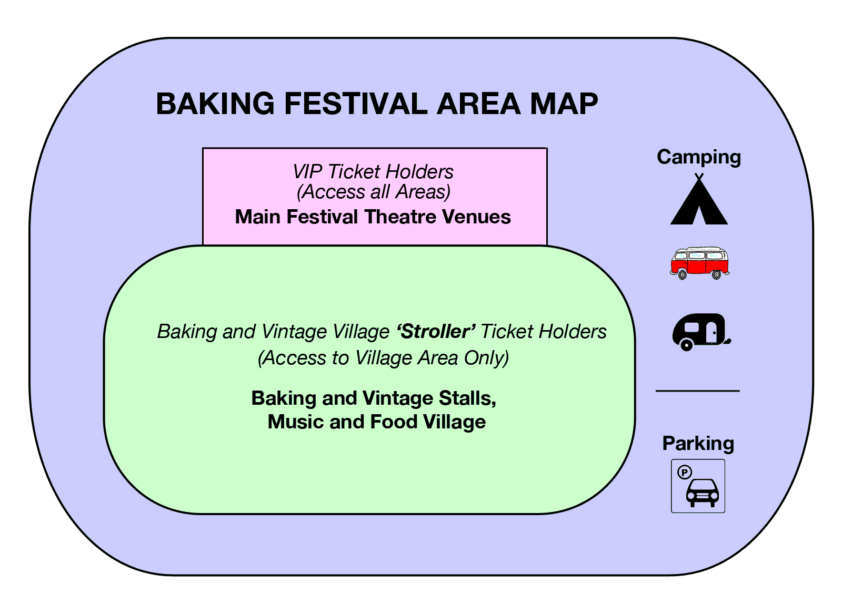
Bakewell Baking Festival - Location
The Showground, Bakewell DE45 1AQ
(Agricultural way Off A6)

